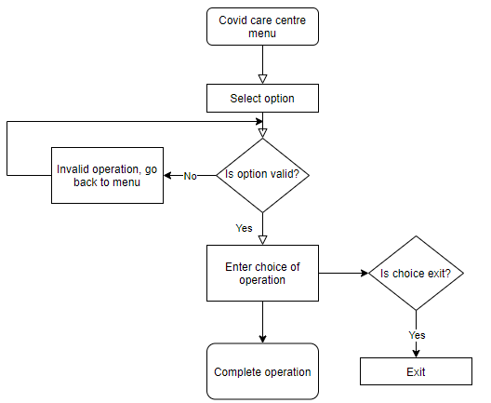

**Behavioural diagram for Covid centre Database Management System**